 | 30 Editors - Spreadsheet
Table of content
Spreadsheet 1
Editortype Menu 2
Header tools and options 2
Object Evaluation State 2
Final 2
Original 2
Node 2
Geometry Component Type 3
Mesh 3
Point Cloud 3
Instances 3
Attribute Domain 3
Point 3
Edge 3
Face 3
Face Corner 3
Toggle Pin 3
Name of the object 3
Selected Only 3
Main region 4
Footer 4

Spreadsheet
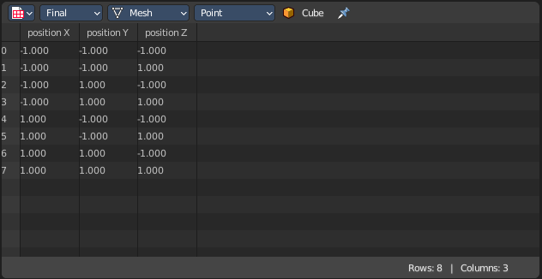
The Spreadsheet Editor allows you to inspect geometry attributes.

Editortype Menu
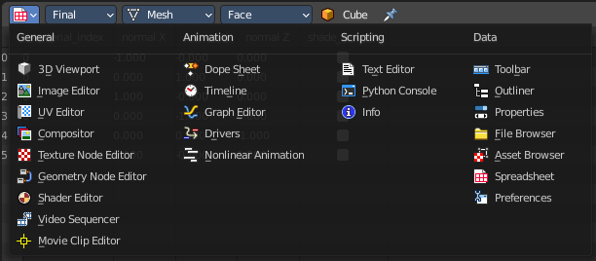
Bforartists is made of several editor types. Headers can display a menu where you can switch to other editor types.

This menu is hidden by default. It is meant to edit the layouts, and should not be necessary for regular work. You can reveal it in the header right click menu.

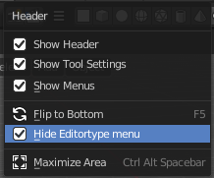

Header tools and options

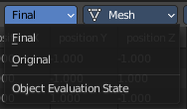

Object Evaluation State
Display the data of an object at different states of its evaluation.

Final
Display the data from object with all modifiers applied.

Original
Display the data from original object without any modifiers applied.

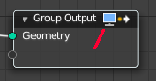
Node
Display the data from the currently active node in the geometry node editor. The active node has the Geometry node output icon in the header on.

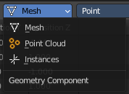
Geometry Component Type
Part of the geometry to display data from.

Mesh
Mesh component containing point, corner, face and edge data.

Point Cloud
Point cloud component containing only point data.

Instances
Display which objects and collections are instanced and their transforms.

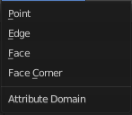
Attribute Domain
Attribute domain to display.

Point
Display attributes that are stored per point.

Edge
Display attributes that are stored per edge.

Face
Display attributes that are stored per face.

Face Corner
Display attributes that are stored per face corner.

Toggle Pin
Keep the data from the pinned object visible, even when another object becomes the active one.

Name of the object
The name of the selected object.

Selected Only
This option is only available if the object is in Edit Mode. When checked, only data for the selected mesh elements is shown.

Main region

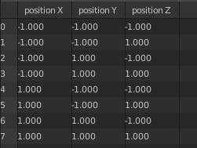
Displays the list of the actual content. This content is dependant of the chosen data types.

Footer

The status bar in the footer shows how many rows and columns there are and how many have been filtered out.

